Assignment PRN211

Name: QuangPNTHE160199

Group 5: Topic Singleton Pattern

Singleton Pattern, one of many C# design patterns, used for ensuring that a class has only 1 instance and provide a global point of access to it.

* UML Diagram:

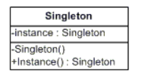

* Singleton Pattern structural code in C#

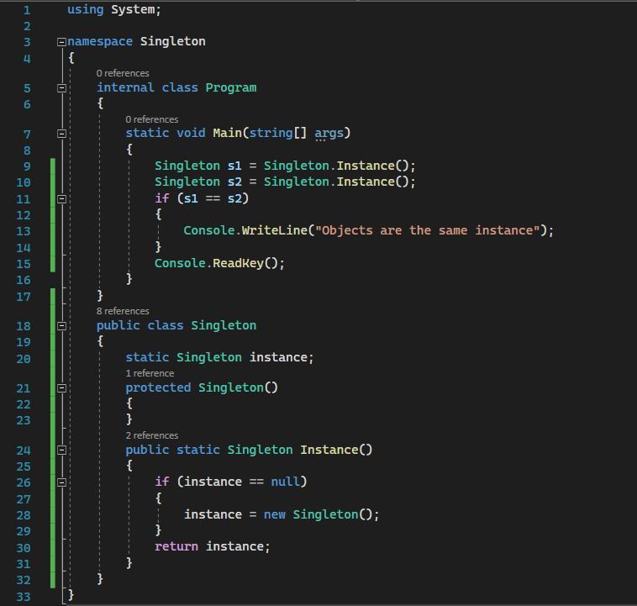

+ Output:



* The following output means that both singleton object s1 and s2 has the same instance provided by singleton pattern
* Singleton Pattern Real World code in C#:

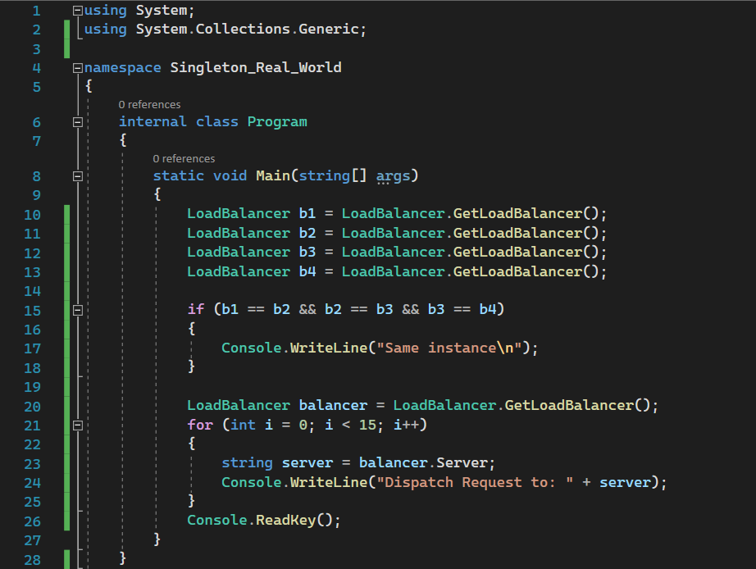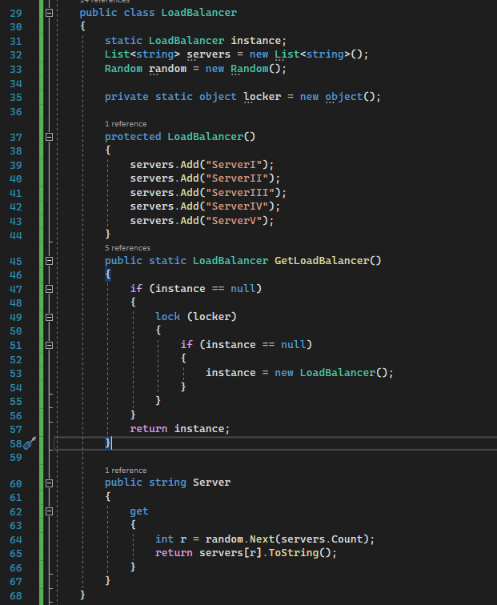

+ Output:



* “Same instance” proves that all LoadBalancer objects b1 b2 b3 b4 all have the same instance. Thanks to singleton pattern, each dispatch request sends request to different server successfully while using only one instance.
* Singleton Pattern also wildly used in projects that require an external resource (file system, database system, web server, ….)